**DLDTHA021 data structures assignment1 Report:**

**GenericsKbArrayApp:**

For the 1st part of the assignment, I designed one class within which there is the main method, it implements a text-based user interface. The class itself has instances to store the term, sentence and confidence score and I initialized the size of the array to a finite size to optimize performance and avoid unnecessary overhead in determining the size dynamically.

My key methods were: the **load()** method which combined both the loading and updating functionality as one to update and load the knowledge base array, this method relies on the **index()** method which looks for the statement in the array using just the term and then it returns the index or a negative 1 if the statement isn’t in the array this helps to see if we need to update or not.

The load method only updates existing statements if the new confidence score is higher than the existing one.

Another key method was the mutator method **set()** which help to change the variables “sentence” and “confidenceScore” for when the updating conditions (higher confidence score) have been met.

**GenericsKbBSTApp**:

For this program I used a pre-existing implementation of a binary tree and binary search tree I got from the notes. I made some changes. To the binary tree I removed the level order traversal method and to the BinaryTreeNode class I added a get method so I can be able to get data contained for a particular node after using my findData method

**MAIN CLASS and how it interacts with the other classes:**

It contains an Inner class “InnerGeneric” that acts as an object of the binary search tree allowing access to its methods, the inner class has instances that store each of the term, sentence and confidence score that is read from either the user or text file for searching or updating

**The inner class has a mutator method, set ():** this method updates the sentence and confidence score if the new confidence is higher

Inside it also I overrode the definition of the of the compareTo method so that each instance of the binary trees is comparable using the terms of each statement.

**The findData () method in the main class**: This method searches for an element in the tree by calling the find method from the BinarySearchTree class which does a recursive search up until it finds said element or return null

**The Insert() method in the main class:** combines both the loading and updating method checking if the new statement exists, if it does it updates it provided the new entry has a higher confidence score and if it does not it creates and new instance to be inserted to the binary tree. It does this by invoking the insert method from the BinarySearchTree class which either creates a new root or recursively seeks a place to insert the new node with its data.

**Testing:**

**Test case 1(For Array): Testing for loading data into the array: using GenericsKB.txt**

**Expected output**: loaded successfully

**Output**: Success

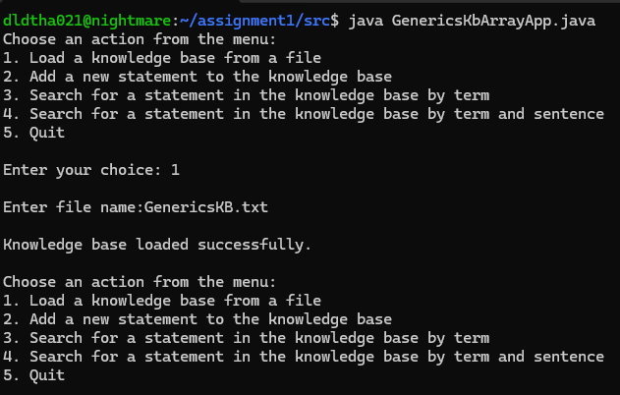Result: success!

**Test case 2(For Array): loading the knowledge base from GenericsKB-additional.txt**

**Expected output:** loaded successfully

**Output:**

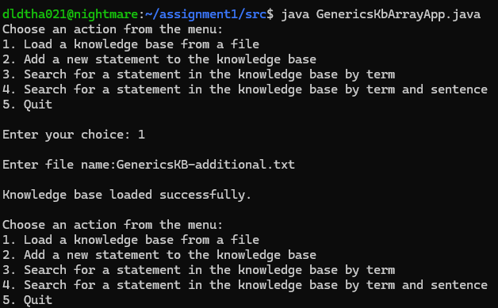**Result:** success!

**Test case 3(For Array):**

**search by term (from GenericsKB.txt)**

**Input provided:** oxidizer

**Expected output:** Statement found: Oxidizers spontaneously emit oxygen at either room temperature or under slight heating. (Confidence score: 0.7951671481132507)

**Outcome:**

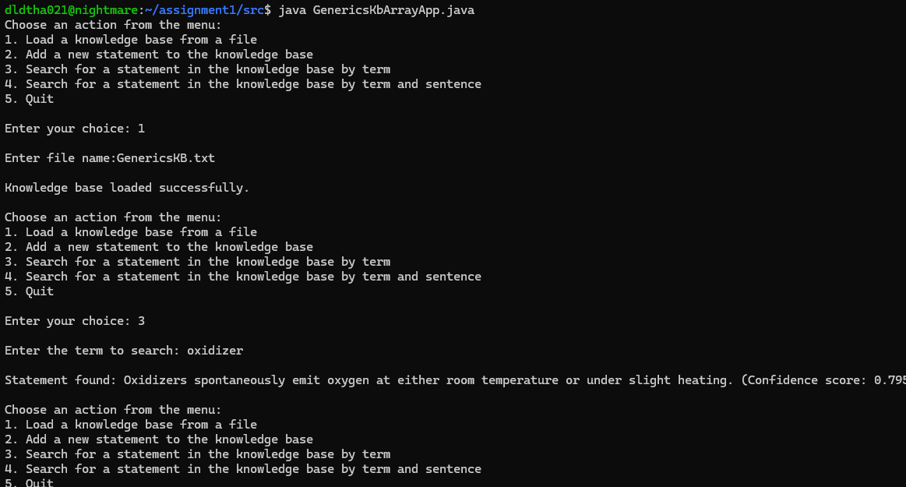

**Result:** success!

**Test case 4(for Array):**

**CHECK TO SEE IF STATEMENT WILL BE UPDATED IF CONFIDENCE SCORE IS HIGHER**

**INPUT: TERM:** Oxidizer

**SENTENCE:** Oxidizers are lovely.

**CONFIDENCE SCORE:** 1.0

**EXPEXTED OUTCOME:** Statement found: Oxidizers are lovely. (Confidence score: 1.0)

**OUTCOME:**

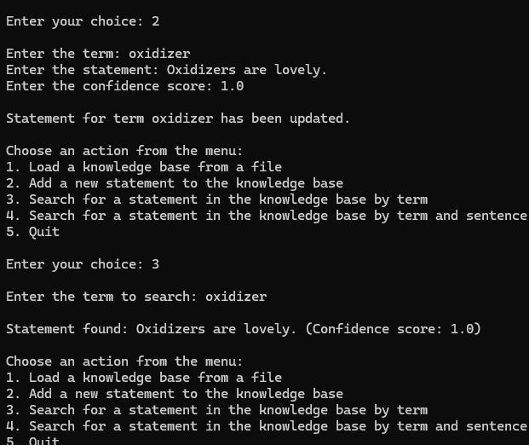**Result:**success!

**Test case 5(for BST):**

**loading into knowledge base**

**Expected outcome:** knowledge base loaded successfully

**Actual outcome:**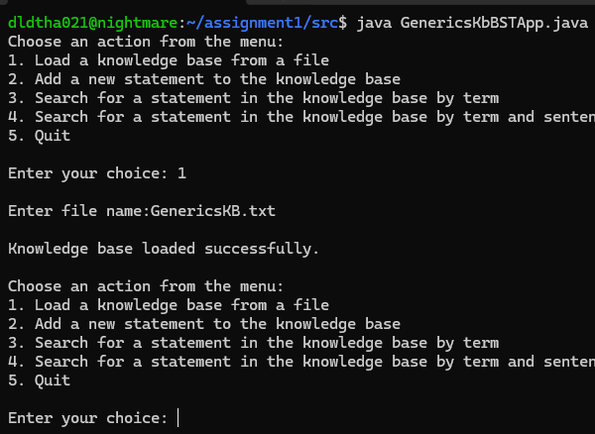

Result: success!

**Test case 6(for BST):**

**updating with a lower confidence score**

**Input: term:** screen pass

**Sentence:** They are the best**, confidence score:** 0.9

**Expected outcome:** “Statement for term screen pass has not been updated, the term's confidence score is lower than existing.

currently the existing information about that term is: A screen pass is an aerial

with a confidence score of: 1.0

I challenge you to find a fact with greater degree of confidence, all the best!”

**Actual outcome: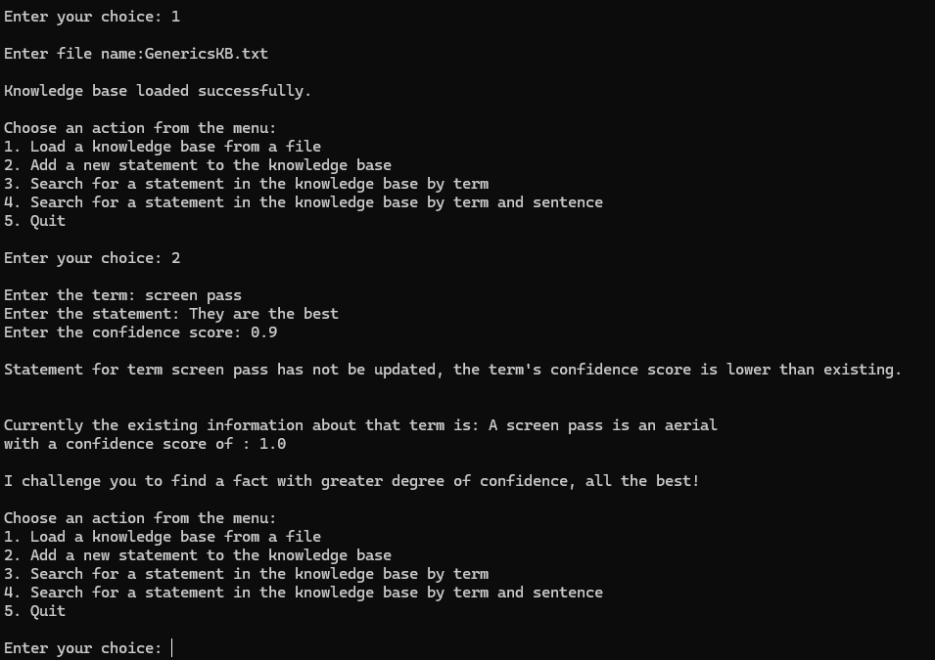result:** success!

**Test case 7(for BST):**

**Testing for invalid confidence scores entered by the user**

**Input: term:** screen pass

**Sentence:** The are required

**Confidence score:** 10 and -1

**Expected output:** The program must be able to tell user that scores are invalid in each scenario.

**Actual output:**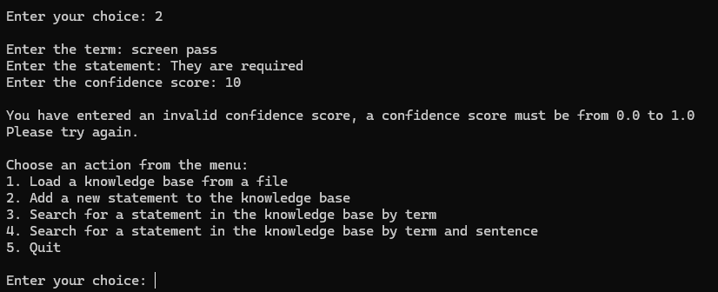

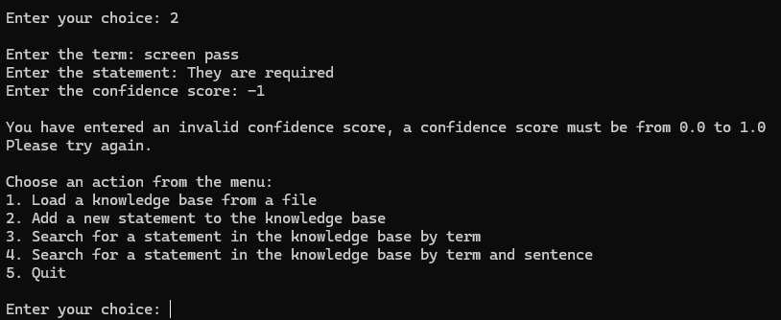

**result:** success!

**Test case 8(for BST):**

**Testing for when the user searches by both term and sentence but the sentence is not a match, now using GenericsKB-additional.txt**

**Test input:**

**Term:** grasshopper

**Sentence:** They jump around a lot.

**The actual sentence for this term is:** “Grasshoppers live in grassy areas and in fields.”

**Expected output:** The program should be able to load this file successfully and,

tell that there is a mismatch between the sentences even though the term is correct and print to the console notifying the user

**Actual outcome: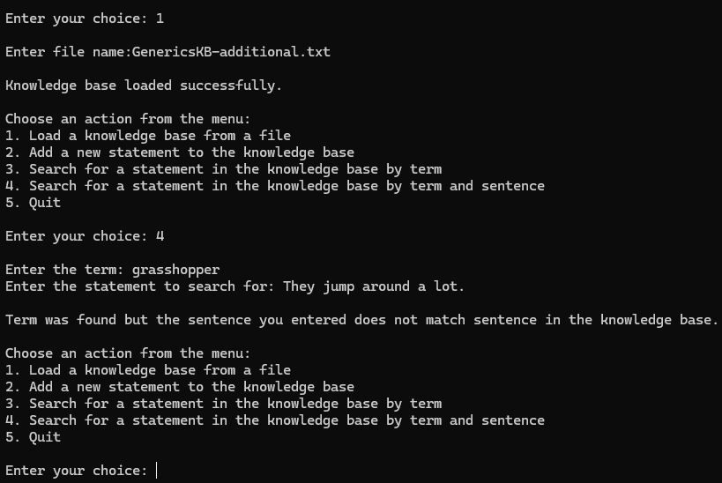result:** success!

**Test case 9(for BST and Array):**

**Testing for when the user enters a wrong file name:**

**Input:**

**Filename:** Wrongfile.txt

**Expected outcome:** the programs should be able to catch this and let the user know that the file was not found.

**Actual outcomes:**

**For BST:**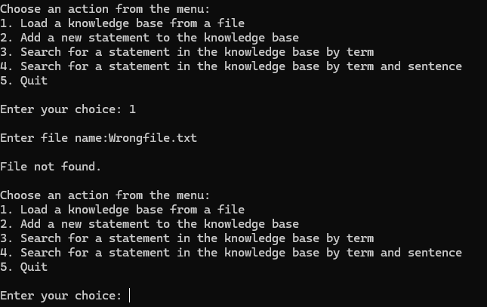

**For Array: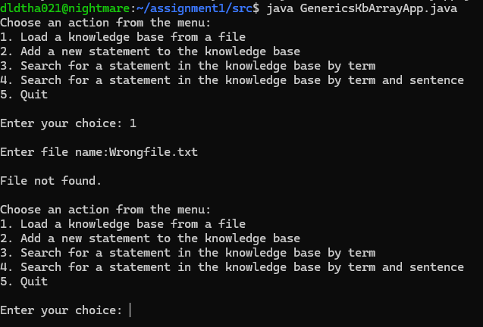in both scenarios the test resulted in success!**

**Creativity:**

In both of my programs I included a small statement that get printed out when the user is trying to update but their confidence score is lower. This part of each program prints out the sentence and confidence score that the user wanted to update and prompts them to seek more information printing the line “I challenge you to find a fact with greater degree of confidence, all the best!”. This makes the user interface friendlier and the program more fun.

I also added an if statement to check if the entered confidence score lies within the accepted boundaries, prompting the user to start over if this condition is not met.

**Git usage:**

0: commit e7d56b33602cf1b39777d4c7928567e69288c4c5

1: Author: Thabo Dladla <DLDTHA021@myuct.ac.za>

2: Date: Mon Mar 17 13:04:41 2025 +0000

3:

4: I fixed a typo in GenericsKbBSTApp file

5:

6: commit 135fb5c2dd8fbc4cb90f8dc5a20e6248ac2a1188

7: Author: Thabo Dladla <DLDTHA021@myuct.ac.za>

8: Date: Mon Mar 17 13:03:24 2025 +0000

9:

...

103: Author: Thabo Dladla <DLDTHA021@myuct.ac.za>

104: Date: Sun Mar 16 23:09:43 2025 +0000

105:

106: I modified the binary tree class

107:

108: commit e80a1dbeea00e68fef5bb28fc2e73d275ce203b2

109: Author: Thabo Dladla <DLDTHA021@myuct.ac.za>

110: Date: Sun Mar 16 22:43:26 2025 +0000

111:

112: added my src folder